**Arduino Cheat sheet**

[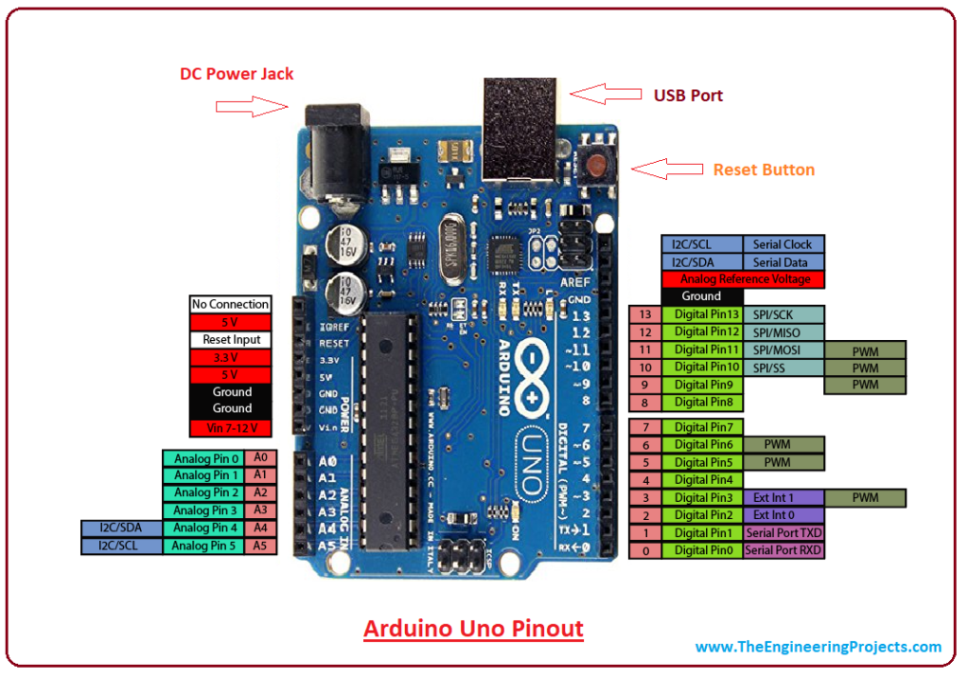](https://www.theengineeringprojects.com/wp-content/uploads/2018/06/Introduction-to-Arduino-UNO.png)

|  |  |  |  |
| --- | --- | --- | --- |
| **General purpose Input Output** | | | |
| Type | Voltage | Values processed as | Notes |
| Digital | 0 or 5 | True or False (Boolean) | Digital input and output can be executed on both digital and analog pins |
| Analog | 0 to 5 | 0 to 1023 (Integer) | Analog input execute on A0 to A5  Analog output execute on D3, D5, D6, D9, D10 and D1 |
| **Communication** | | | |
| Type | Notes | | |
| UART | Communications pins execute on pins mark Tx and Rx.  Arduino library required for UART communication: HardwareSerial.h  NOTE: This has already built in in every Arduino program that involves with the object Serial | | |
| I2C | Communications pins perform on pins mark SCL and SDA.  Arduino library required for I2C communication: Wire.h | | |
| SPI | Communications pins perform on pins mark SCK, MISO, MOSI and SS.  Arduino library required for I2C communication: SPI.h | | |

Arduino reference (Links)

|  |  |  |  |
| --- | --- | --- | --- |
| [Libraries](https://www.arduino.cc/en/Reference/Libraries) | [Functions / Variables / Structures](https://www.arduino.cc/en/Reference/Libraries) | [Beginner’s Ebook](https://www.esc19.net/cms/lib011/TX01933775/Centricity/Domain/110/make_gettingstartedwitharduino_3rdedition.pdf) | [Beginner’s Code guide](https://www.google.com/url?sa=t&rct=j&q=&esrc=s&source=web&cd=3&ved=2ahUKEwiciIDUm-fnAhVYzTgGHUbWBQQQFjACegQIBBAB&url=https%3A%2F%2Fwww.electricallab.gr%2Fe-yliko%2Farduino%2F1009-c-programming-for-arduino%2Ffile&usg=AOvVaw3pIWtlPVEM55t0KIMzK9id) |

Simulator

[Tinkercad](https://www.tinkercad.com/)